*Name Change Proposal*:

**LISABER**: **L**ow cost **I**n-Situ laser camera **S**ystem **A**imed at ice ocean **B**oundaries for bubble **E**mission and **R**esearch

Username: Pi

Password: messi10

Ethernet: 192.168.3.3?

Wlan0: 10.0.1.12

*Standard Operating Procedure*

The LCS (laser camera system) is an ongoing project focusing on developing an optical instrument capable of recording data at an ice ocean boundary such as a glacier or icebergs. Whether the data is collecting scans of iceberg faces or tracking bubbles, this instrument should get the job done at a reasonable price and precision. This document will explain how the laser camera system functions, as well as explain the necessary components and future work required to make this optical instrument the best it can be.

Before diving into the details of each component, it is imperative to understand that this instrument requires some knowledge in optics, electronic, and programming. For this reason, the document will dive into each part of the system and explain how each component relate to one of these areas. Now, the system is divided into 3 distinct parts: the “brain”, the laser, and the camera. Each of these parts are contained in their respective pressure housing. This document will go over the laser, the brain and finally the camera, where much of the future work is needed.

*The Laser*

**Optics**

The laser currently being used is a class 4 [green laser pointer](https://biglasers.com/product/gx-green-laser-pointer/) from Big Laser Pointers. It is a 750mW output continuous wave green laser with a wavelength of 532 nm and a beam diameter of 2 mm. This laser was specifically chosen because green laser typically can penetrate water with sufficient power without significant amount of scattering. This laser has a s[mall beam divergence](https://en.wikipedia.org/wiki/Beam_divergence) (1.5 milliradians) meaning, the width of the laser sheet does not increase as much with distance.

The produced laser sheet is made possible with a powell lens. This lens produces a more uniform laser sheet compared to the previous version that used cylindrical lenses - where most of the intensity of the laser is focused on the center.

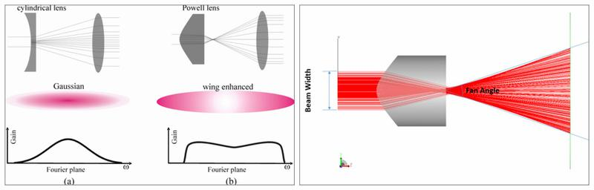

Overall, this lens was selected because this single lens was easier to work with than the previous combination of lens which required perfect alignment of each lens and enough space for an optical track to fit inside a pressure housing. The specific lens used in this system is a [45 degree fan angle powell lens](https://www.edmundoptics.com/p/45-deg-full-fan-angle-laser-line-generator-lens/5073/) (8.9 mm diameter) from Edmund Optics. This lens is coated for this wavelength and does prevent some backward reflection, but overall having black printed parts does reduce most of the reflection. The fan angle is calculated from where the laser leaves the Powell prism and hits the air medium. The angle of 45 degrees was chosen because it would produce a longer laser sheet than the previous laser sheet at the same working distance of around 50 cm.

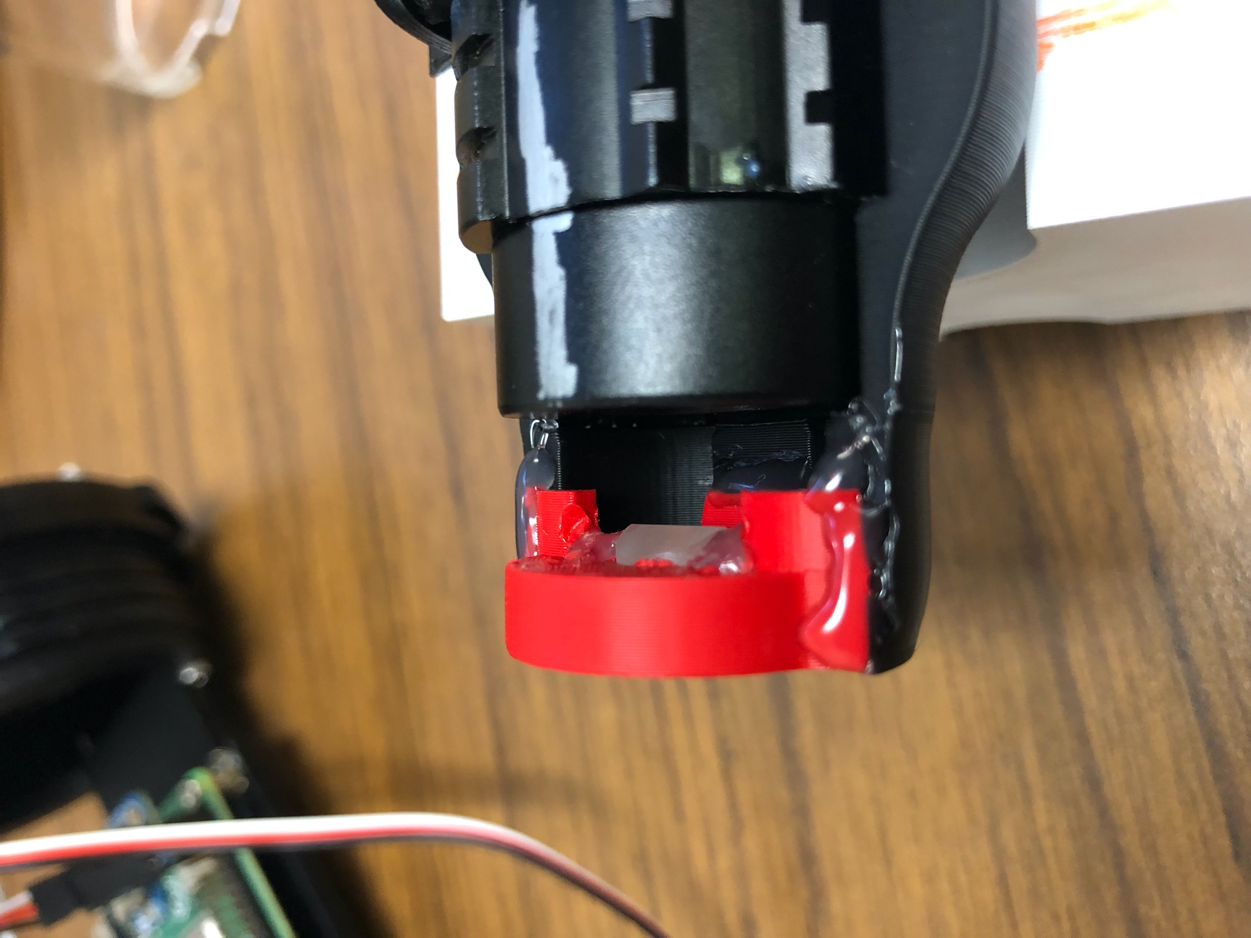

The lens must have its triangular edge facing the laser horizontally and its back side flushed with the 3d printed holder and the end of the optical track so the laser sheet can pass through the acrylic end cap without damaging anything inside the pressure housing. The lens is glued to the lens holder and the holder is glued to the optical track.

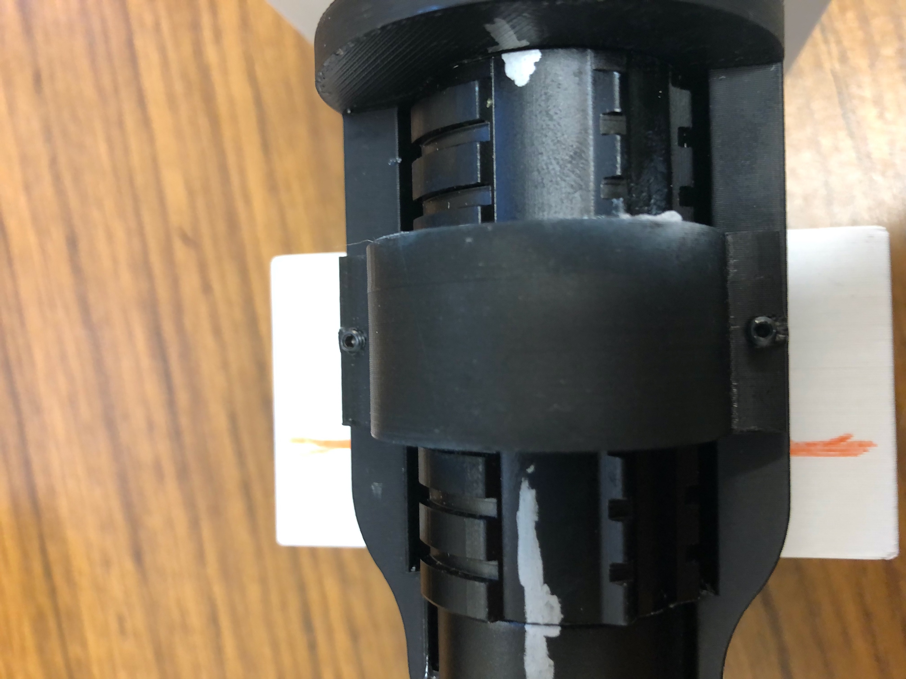

The laser is secured in placed with a clamp that uses 2 set screws that screw onto the optical track. The marks on the laser and optical track are alignments.

**Electronics**

The laser driver board was left untouched and is still in its original state. To power the laser, a black wire is soldered to the spring that came the laser (where the negative end of a battery would sit) and a red wire is connected to the threaded part of the laser (where the original sealing for the positive end of the battery was).

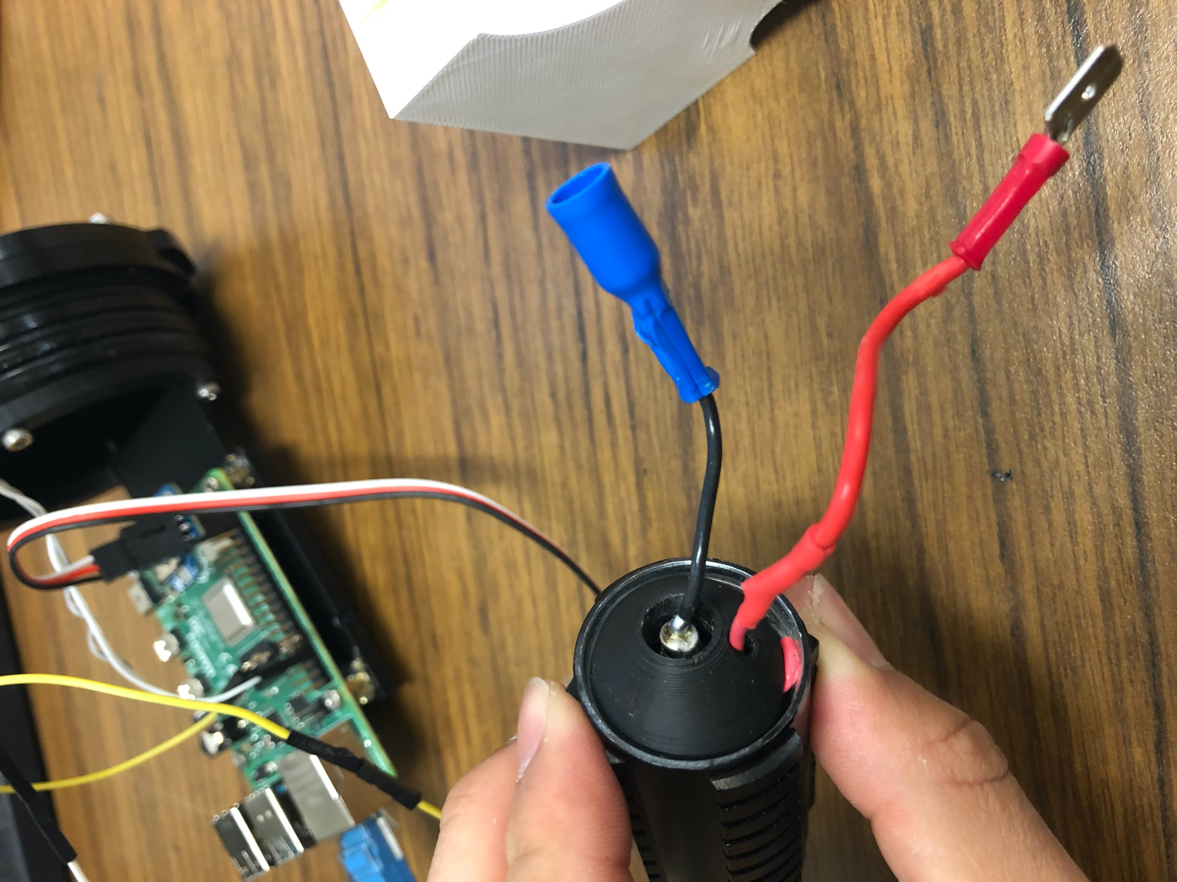 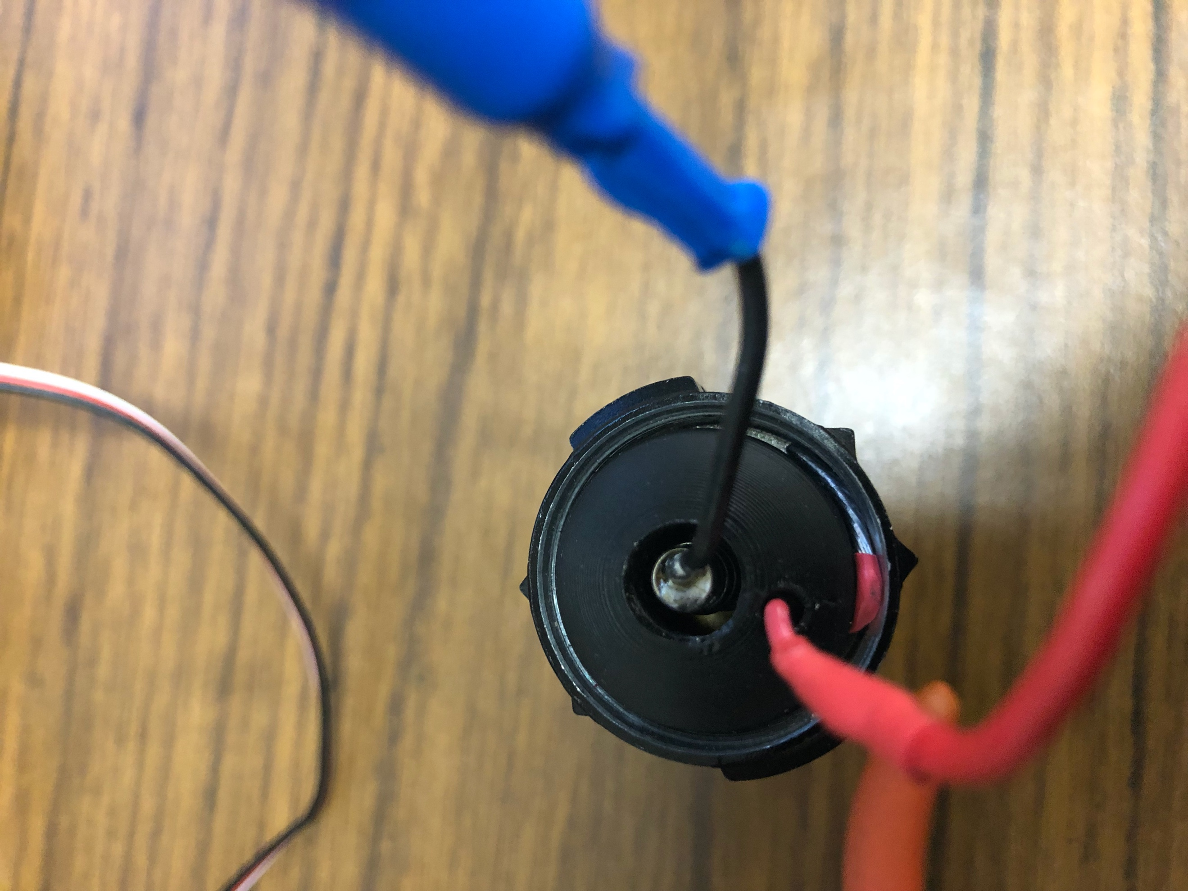

A 3d printed part is placed so that both are safely connected and won’t encounter each other. It is important to know that this part is tightly fit so that the red wire can touch the end and complete the circuit. I highly recommend not moving this piece too much or else the wire can loosen up and end up shorting the laser or worse.

***FUTURE WORK 1: work on soldering the red wire in place or an alternative way to safely securing the wire in place***

Along with the laser and lens, a pcb board is also in this pressure housing. The pcb contains a mosfet and two resistors. This pcb board is what allows the laser to turn on and off via a mosfet switch. A circuit diagram is shown below. An arbitrary RPi I/O pin was used in this diagram, please be sure to check what the wire is actually connected to. The mosfet used in this circuit is [HEXFET Power MOSFET](https://www.digikey.com/en/products/detail/infineon-technologies/IRLB8721PBF/2127670?utm_adgroup=&utm_source=google&utm_medium=cpc&utm_campaign=PMax%20Shopping_Product_Medium%20ROAS%20Categories&utm_term=&utm_content=&utm_id=go_cmp-20223376311_adg-_ad-__dev-c_ext-_prd-_sig-Cj0KCQjw_-GxBhC1ARIsADGgDjtAh20fBBu4TbjjMNzqmQ8iPAKLoYnPWcDOqGaXRpcrlJhr0w35ucoaAjacEALw_wcB&gad_source=1&gclid=Cj0KCQjw_-GxBhC1ARIsADGgDjtAh20fBBu4TbjjMNzqmQ8iPAKLoYnPWcDOqGaXRpcrlJhr0w35ucoaAjacEALw_wcB), rated for 30V and 44A. A high drain current was needed because it needs to dissipate the power needed to turn on the laser. This mosfet has gate threshold voltage of 1.8V (min = 1.35V and max = 2.35V). The rise time of the saturated region is 93 ns with a time delay of 9.1 ns and the fall time to revert to unsaturated region is 17 ns with a delay time of 9 ns. These values are important if you want the laser to pulse at a high frequency, but it is not the case in this project. The pinout of the mosfet is shown below.

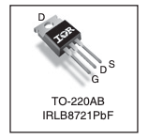

D is the drain channel, G is the gate channel, and S is the source channel. In the circuit diagram below, we have the mosfet drain at the top channel, the gate channel as the middle one, and the source is the bottom channel.

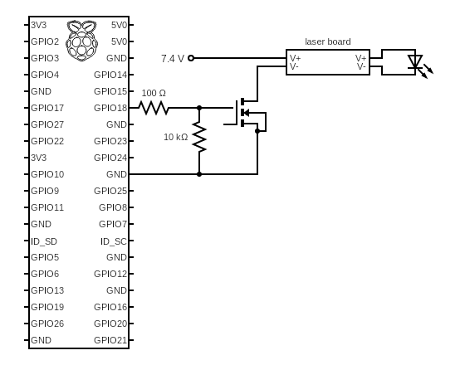s

The way a mosfet switch circuit works is when the voltage being supplied to the gate channel of the mosfet exceeds the threshold voltage, the region between the drain and source becomes saturated and allows the current to flow between the two channels. A 100-ohm resistor is placed in series with the I/O pin from the raspberry pi and the gate channel as a safety precaution. The 10 kiloohm resistor is used as a pull-down resistor to prevent reverse current draw to the Pi. Since the positive voltage supply is connected to the laser’s red wire and the laser’s black wire is connected to the drain channel, the flow of electrons will now complete and finally, the laser is now able to turn on or off via an I/O pin. This means to turn on the laser, the voltage supplied from the I/O pin to the gate channel must continuously supply the voltage. Turning off the laser means to stop supplying any voltage to the gate channel.

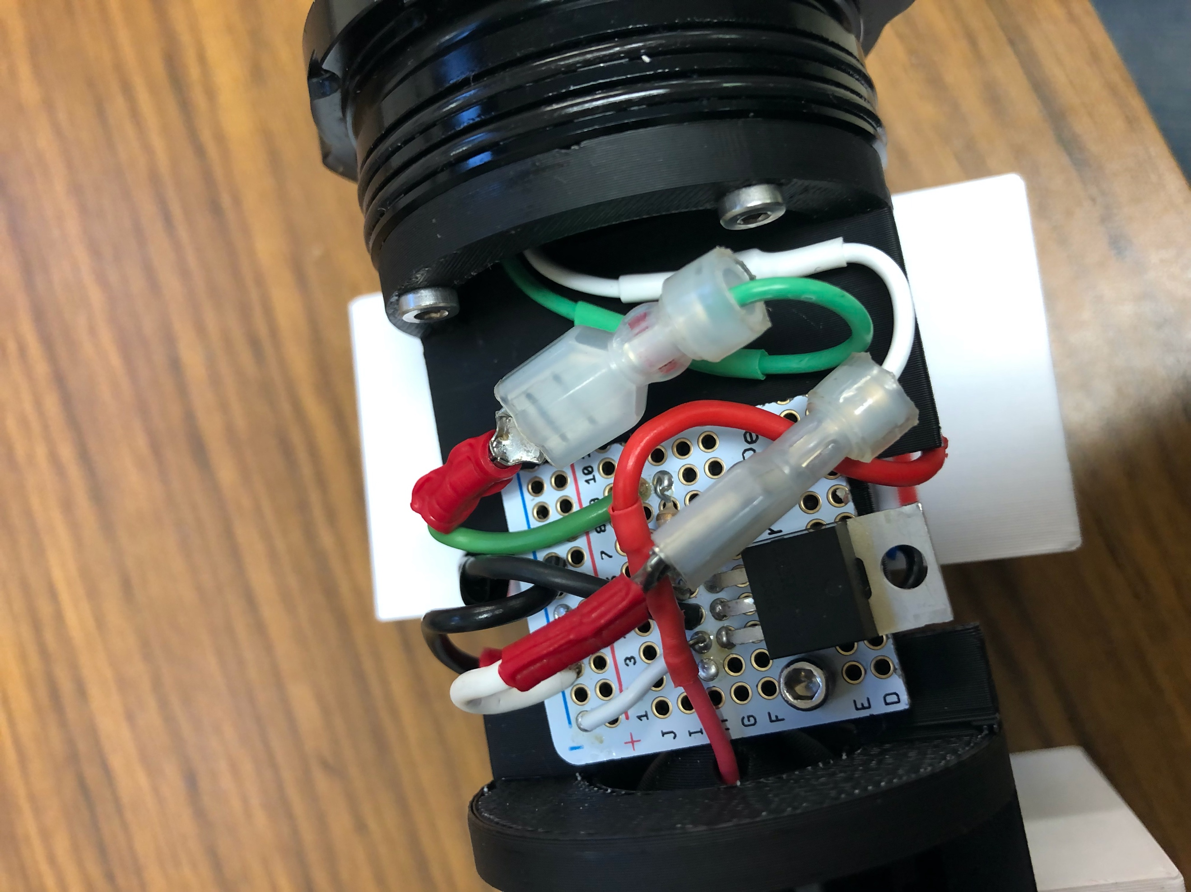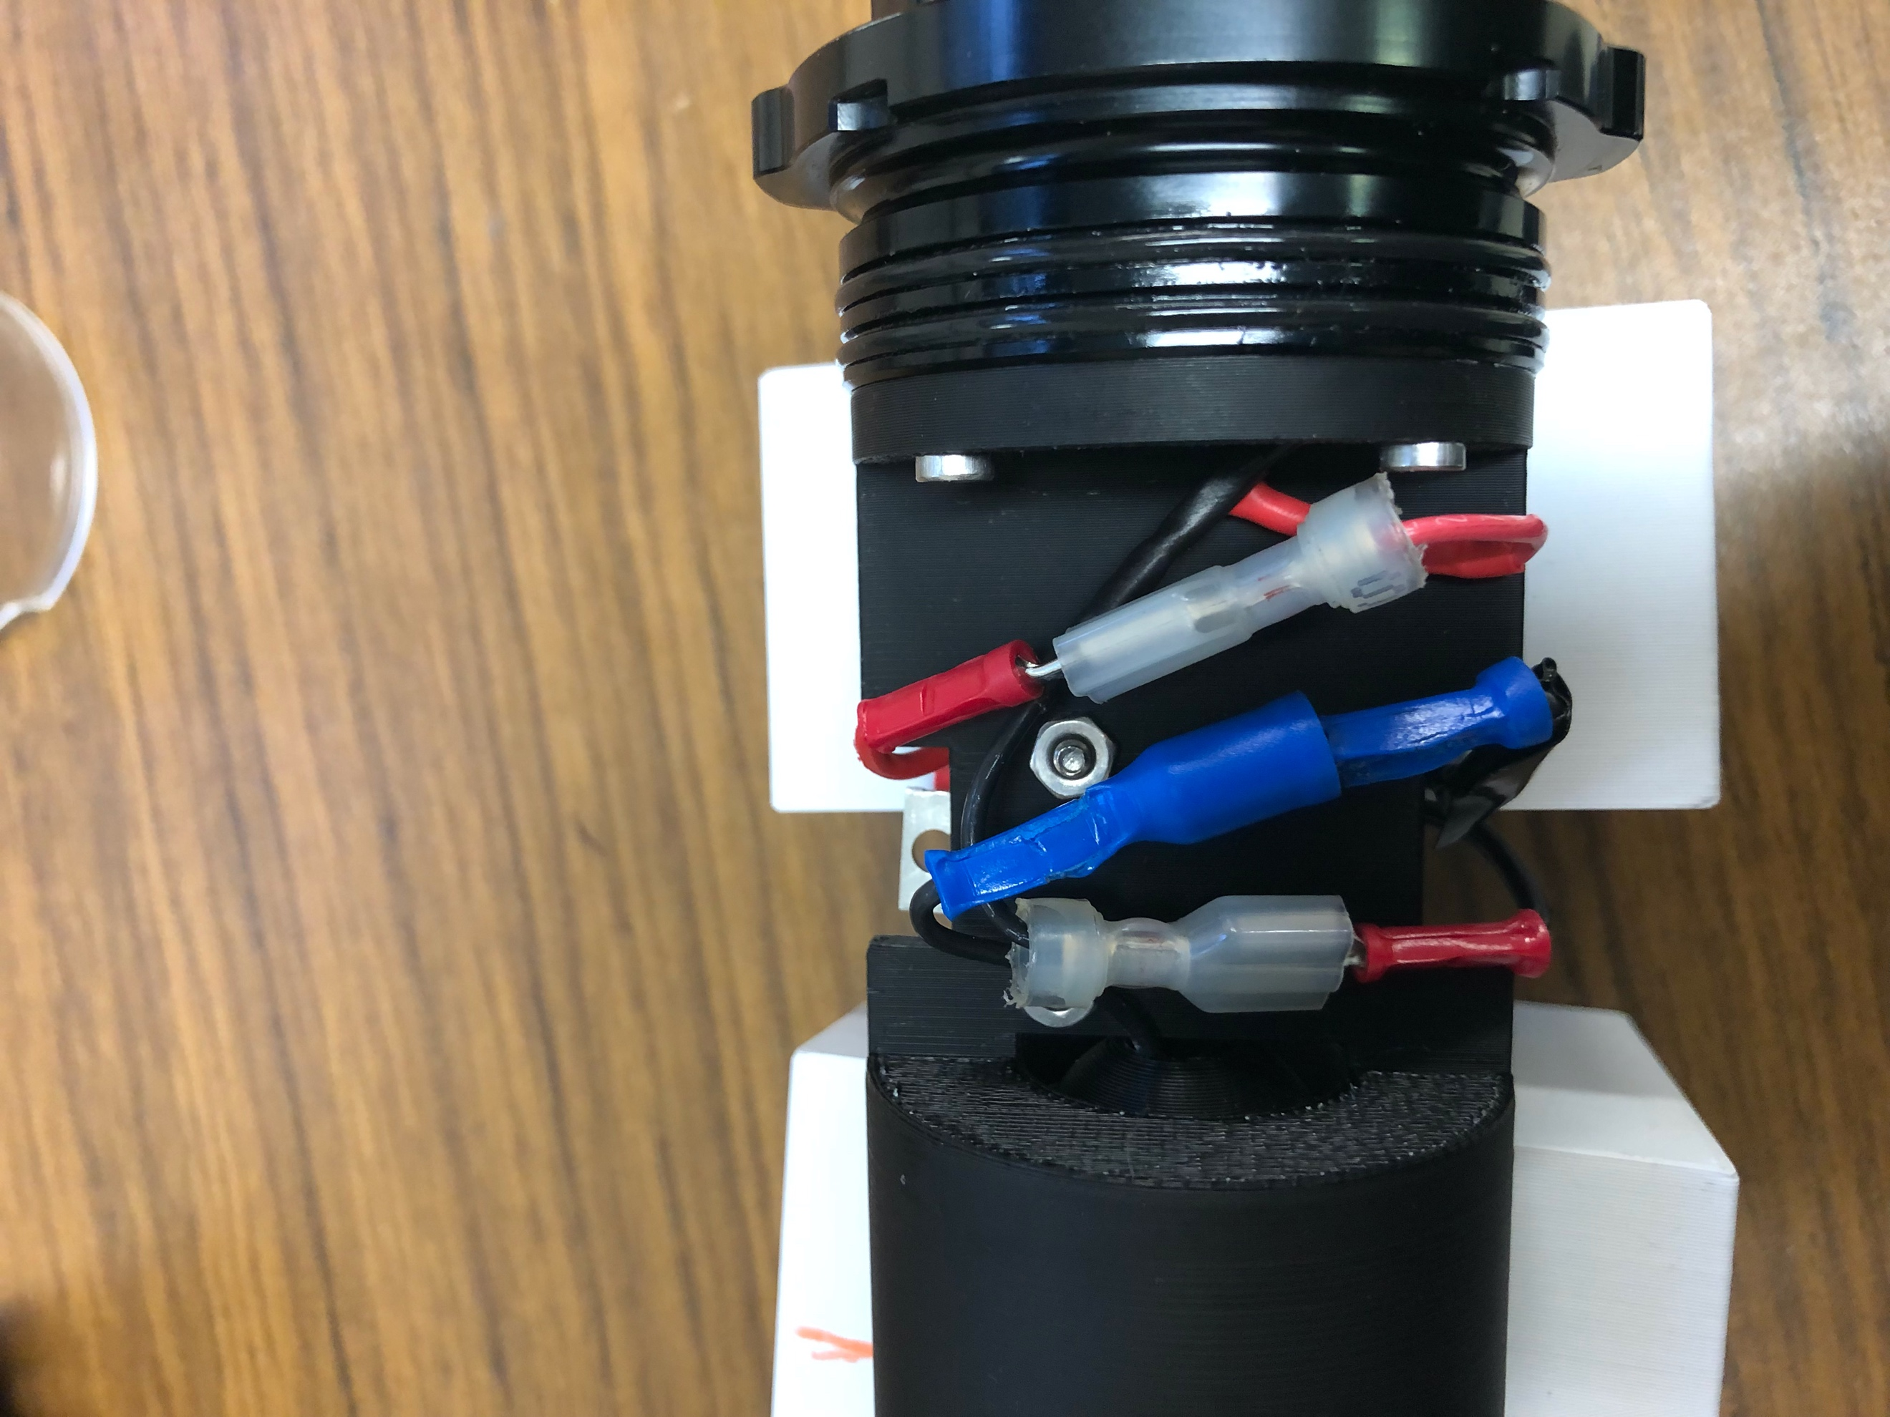

This pressure housing contains a 4-wire cable: white = GND, black = negative power, green = I/O, red = positive power. The pcb board is bolted down with m3 screws + nuts. One thing to note is that the negative power of the laser is grounded with the white wire on the pcb board. Depending the mode of laser (continuously on/pulsed), the power consumption will vary. The continuous mode draws 1.1 A while the pulsed mode draws 0.6 A, both having the same voltage requirement of 7.4V. In addition, the gate channel is drawing power with the 3.3V supply and 100 ohm resistor – around 110 mA.

**Summary –** The laser part of the system is meant to fit inside a 2 in diameter, 150 mm long pressure housing. This part of the system holds the laser, lens, and pcb board that allows the laser to turn on/off, all mounted on a 3d printed optical track. The lens produces a laser sheet that depends on the working distance. The 3 most important values are the fan angle which is 45 degrees (experimentally measured to be 47 degrees), the beam divergence to be 1.5 milliradians, and the beam diameter is 2 mm. Simple trigonometry is used to calculate laser sheet height and width using these values and the working distance. When this laser part is used in the field, it is important to know that there is refraction occurring at the acrylic end cap and water interfaces.

*The ”Brain”*

**Electronics**

As the name implies, the “brain” of the LCS is where system is told what to do, when to do it, and record the data. The main component of the brain is the Raspberry Pi 4. It is powered by a 5V line from a [blue robotics stepdown converter](https://bluerobotics.com/store/comm-control-power/control/bec-5v6a-r1/) that is connected to a [2S LiPo battery](https://hobbyking.com/en_us/zippy-compact-5000mah-2s1p-40c.html). The LiPo battery has a capacity of 5000 mAh and a voltage of 7.4V at a discharge of 40C(80C burst). The 5V line from the voltage converter should connect to the 5V and GND pins on the right upper corner of the Pi. You should note that this also where [a real time clock (RTC)](https://www.adafruit.com/product/3386?gad_source=1&gclid=Cj0KCQjwudexBhDKARIsAI-GWYUrZHtgEpditJVvg7P9sk7NwpOkE5kRrcFGnQzP4tu9_firdcSSQtYaAjTMEALw_wcB) is also connected. This rtc is specifically designed for a raspberry pi, meaning you should push into the I/O (no soldering required) as shown in the picture below.

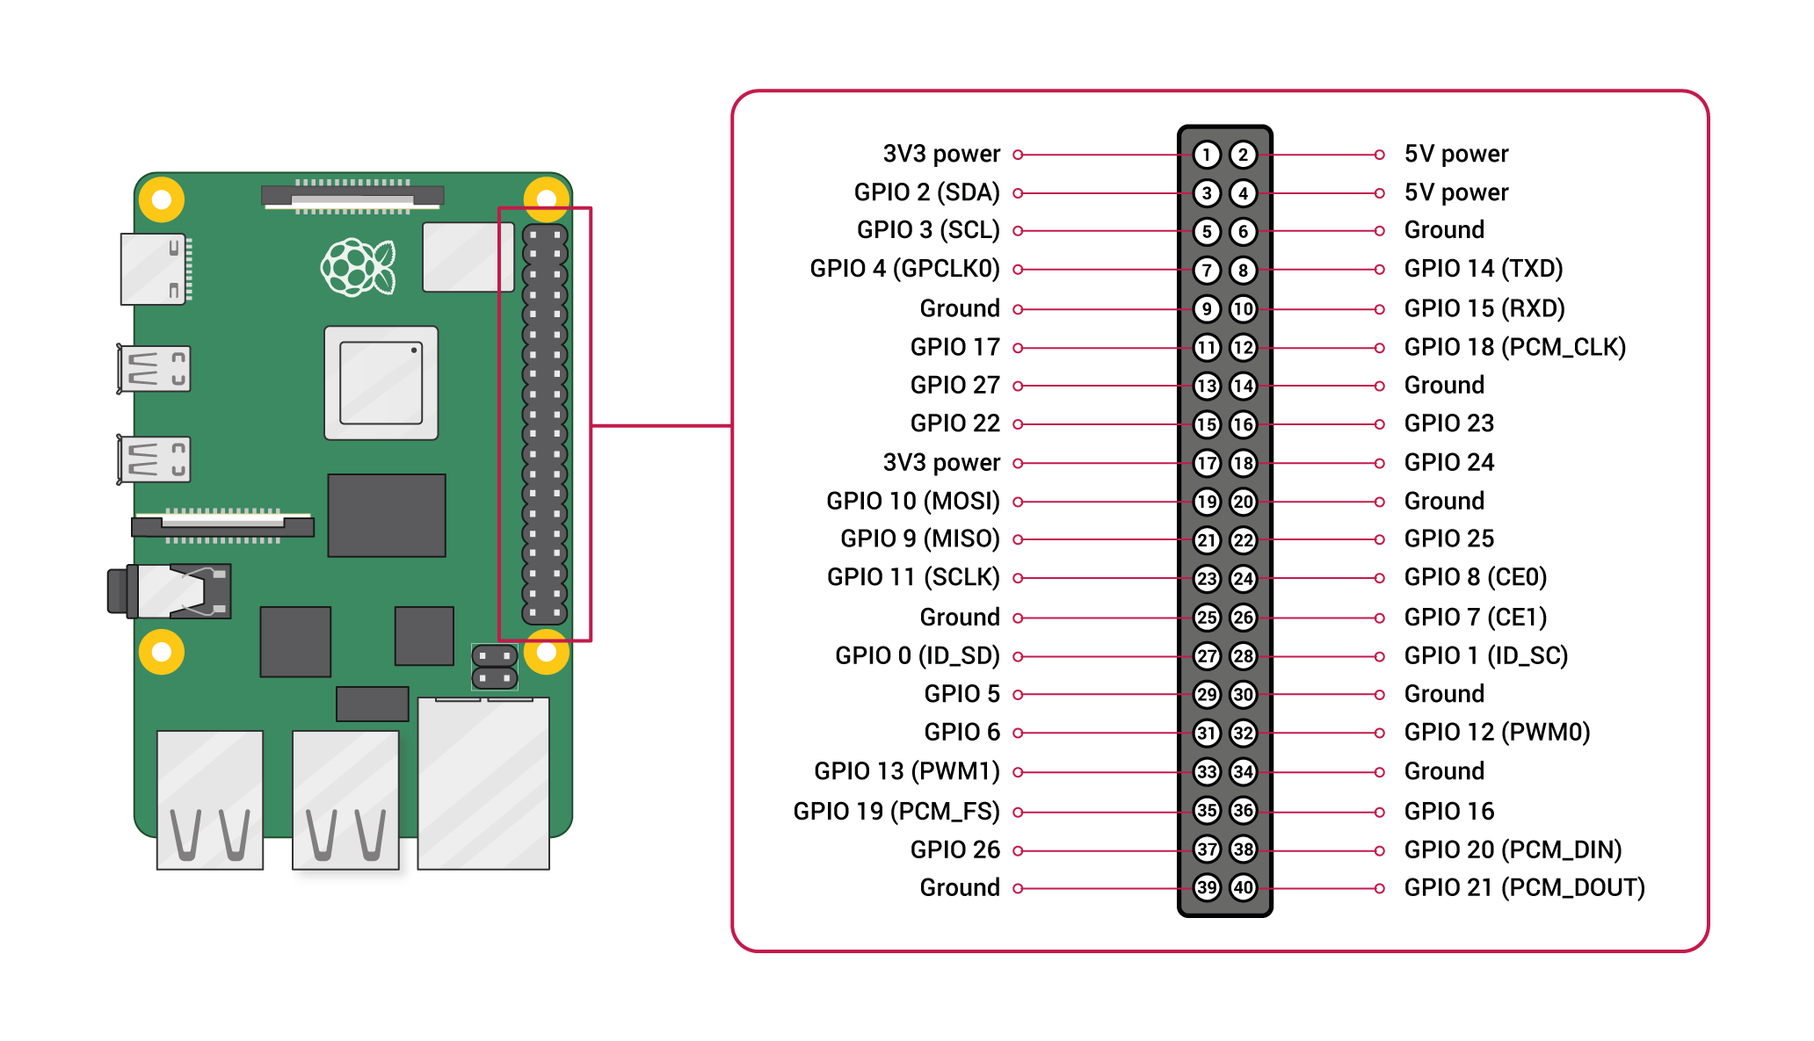

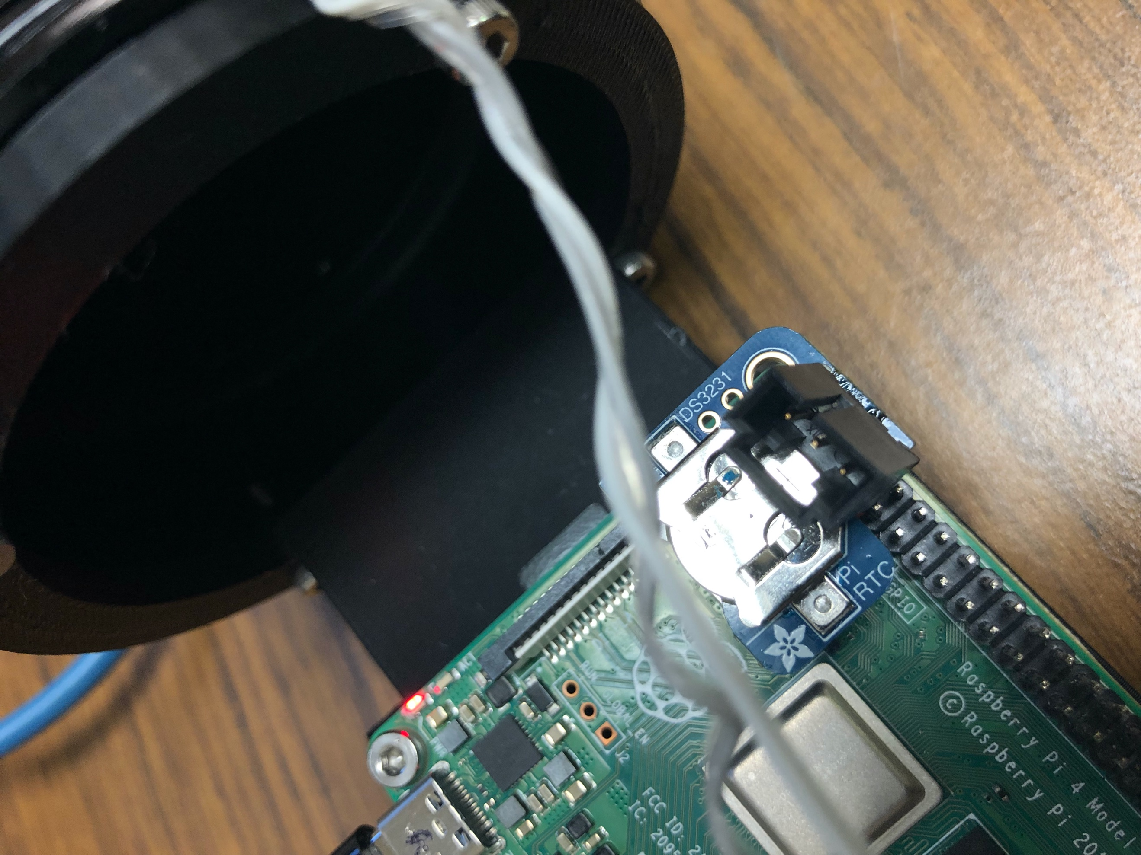

The four pins used for the rtc are the 5V, GND, the SDA (serial data line) and SCL (serial clock line). The clock can tell precise time due to its DS3231 module. A CR1220 coin cell battery is required so that the rtc can keep time even when power is lost. The real time clock is already calibrated and ready to use but if there is a need for recalibration or looking into some potential issue, the process of setting up that can be found [here](https://learn.adafruit.com/adding-a-real-time-clock-to-raspberry-pi/overview).

The other 5V voltage line from the voltage converter in soldered to a step-up voltage converter that supplies power to the camera. This voltage converter was given to me by Noah, but it is important to note that it can handle up to 5A and the output voltage is adjustable, by turning the knob on the side of the blue box. This voltage converter is glued to the printed housing and is already set to supply the 13V required for the camera.

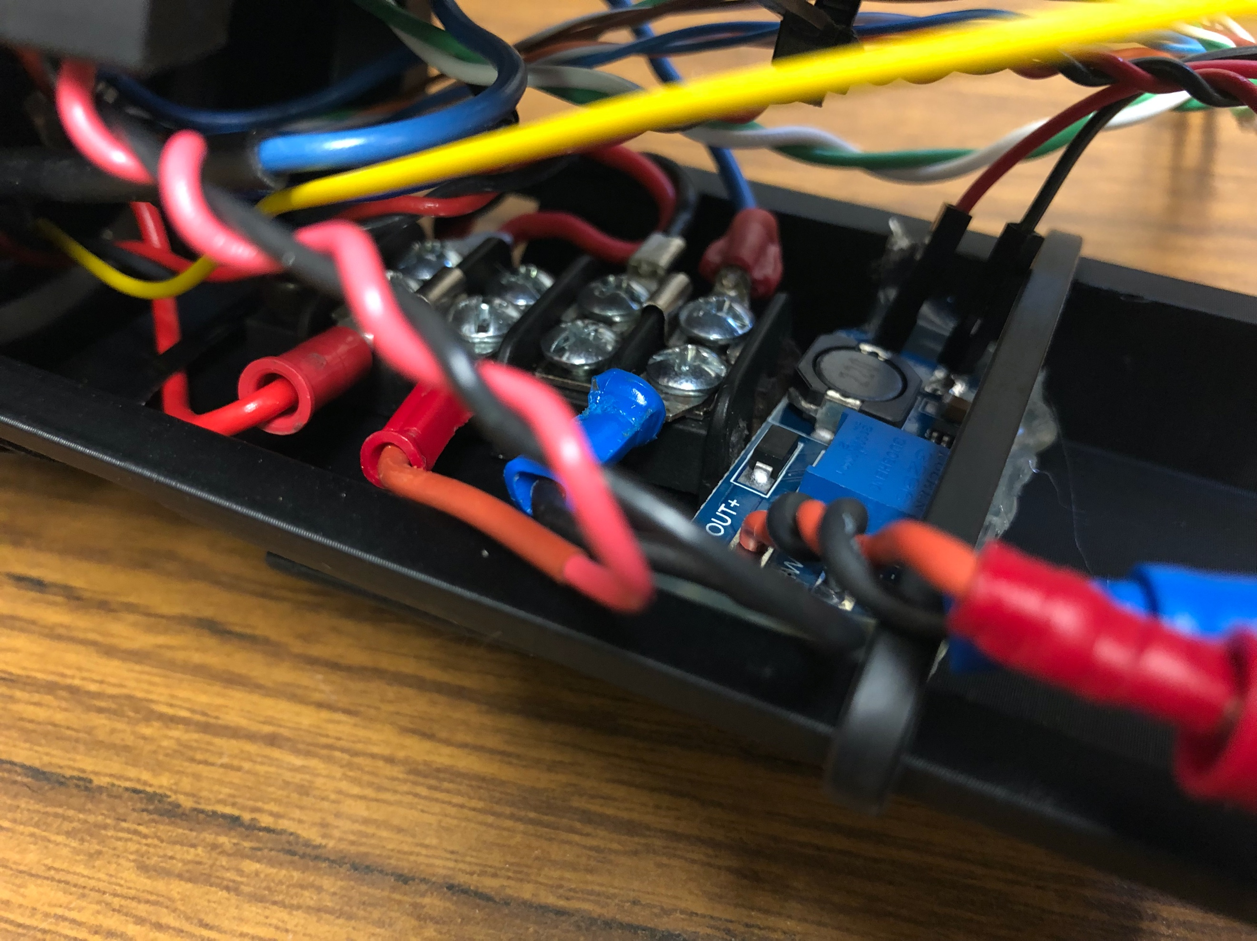

The LiPo battery connects to a bus, where it can safely deliver the voltage requirement each electronic component needs. The positive end of the battery is connected directly to the bus while the negative passes through [an blue robotics analog switch](https://bluerobotics.com/store/comm-control-power/switch/switch-10-5a-r1/).

***Future Work 2: include a battery monitor so that the battery is not damaged and can be rechargeable. A simple monitor circuit and python script that programs the circuit was given to me by Noah. This can be incorporated to the circuit.***

The switch has two terminals. One terminal connects to the negative end of the battery while the other terminal connects to the bus. With the two ends of the battery now being able to complete its current, the results are two sides of the bus: one side being for the positive voltage and the other side being for the negative voltage. It is important to know which side is which so that nothing is accidently shorted. The side closer to the cap is the positive while the side closer to the Pi is the negative. Please refer to the image below to see the specific layout of the wiring for the bus. The bus is bolted mounted to the print with 2 M4 screws and nuts.

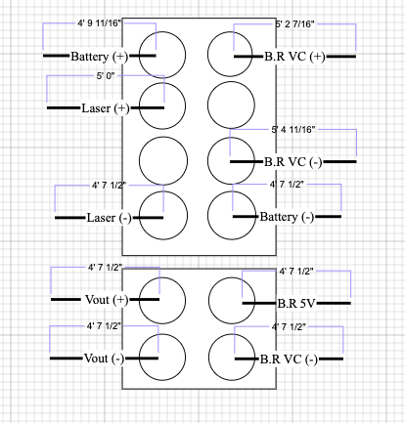

In the “brain” pressure housing, there is also an Ethernet cable that connects to the raspberry pi. It is set of 8 wires, and it is for the camera. There is some clearance for a flash drive, that would connect to the USB port of the Pi.

***Future Work 3: Ensure a way the ethernet wiring does not interfere the space where the flash drive will be.***

The GPIO pins from the raspberry pi supplies 3.3V or 0V. This satisfies the necessary condition of surpassing the threshold voltage of the mosfet in the laser housing and GPIO pinout on the camera ( >2.0V). The pin that should supply the voltage to the mosfet and camera gpio should be one that is able to do I/O functions and output PWM signals. The one that is used currently is GPIO 12 – which is found on the lower right on the Raspberry Pi GPIOs. This pin has 2 connections – the grey/green wire is for the laser and the yellow wire for the camera. The white wire is connected to one of the ground pins. Refer to the images below if unsure of the pinouts.

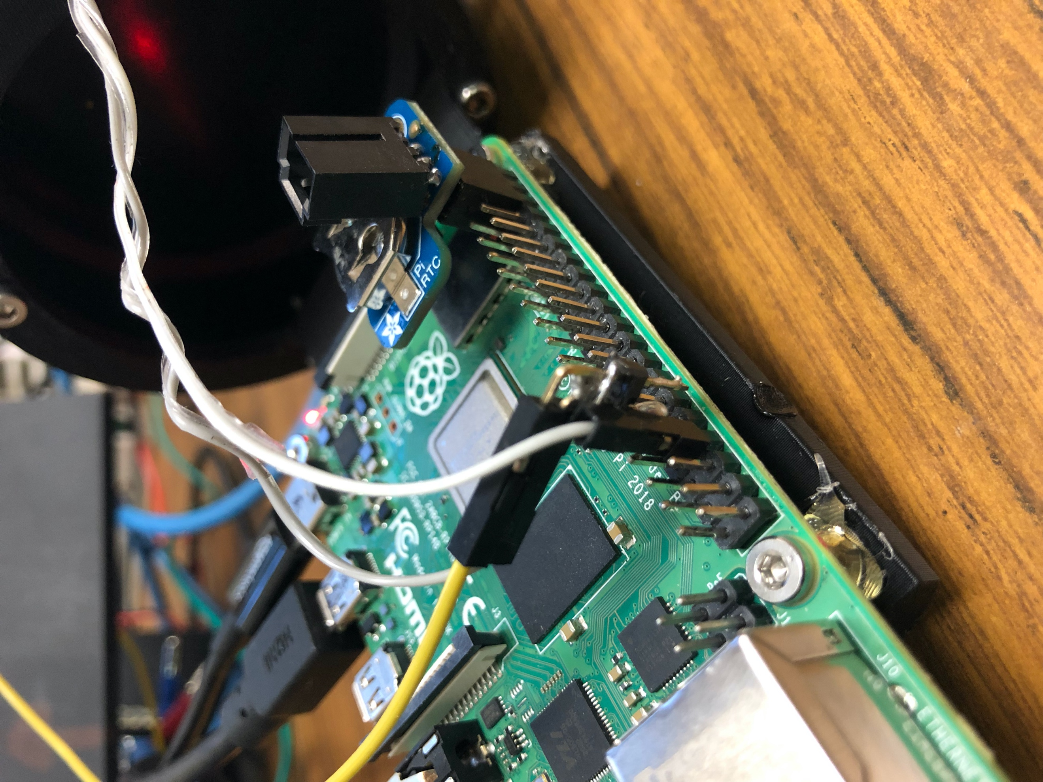



**Programming**

The laser camera system is programmed to start upon boot, meaning once power is on via turning the switch, it will run a python script which controls laser, camera, and storing. The python script that is set up to run upon boot is found in the reu directory under the name lasertest.py. The final script that should be written and used in the field is not complete and still in the works, but this subsection will explain the commands so far that controls the laser and dives into the idea on controlling the camera and data storing. The script is already set to start upon boot, all there is to do is to fill the content of the script.

The laser can be put into a continuous mode or a pulsed mode, depending on the way you program the I/O to supply a voltage on the Pi. Both modes require the same library from python:

Import RPi.GPIO as GPIO

Pinnumber = 12. #this can be any pin on the raspberry but 12 was chosen because it can also output pwm signals which is needed for the pulse mode#

GPIO.setmode(GPIO.BCM)

GPIO.setwarnings(True)

GPIO.setup(pinnumber, GPIO.OUT)

The differences now for each mode is the lines of code after the initializing of the pin. For the continuous mode, it would look like this:

Import RPi.GPIO as GPIO

Pinnumber = 12.

Def button(logiclevel): #only valid inputs are 0 and 1

GPIO.setmode(GPIO.BCM)

GPIO.setwarnings(True)

GPIO.setup(pinnumber, GPIO.OUT)

If logiclevel == 1;

Return GPIO.output (pinnumber,logiclevel)

If logiclevel == 0;

Return GPIO.output(pinnumber, logiclevel)

Button (0)

Button (1)

Sleep(x) #where x is the amount of time laser will be on

Button (0)

GPIO.cleanup()

Indicating the logic level of 1 is supplying the 3.3 voltage to the gate channel of the mosfet while 0 is supplying no voltage. Button (0) is the first command before button(1) is to be sure that the laser is not accidental turned once power is supplied to the whole system. After ‘x’ amount of time passes by, button(0) is called to turn off the laser. GPIO.cleanup() is used to make sure all pins are correctly reset to prevent accidental turn ons/offs. This laser can stay on as long as it wants but keep in mind the laser does get hot after a certain amount of time and battery consumption is crucial especially when relying on having the system to last for the entire deployment.

***Future Work 4: These lines can be edited to better suit the needs of the scientists such as writing another function that has the button commands and a sleep command or make the whole thing a class.***

For the pulsed mode, the commands look like this:

Import RPi.GPIO as GPIO

Pinnumber = 12.

Def lasertimeon(freq,dc): #inputs are the frequency in hz and the duty cycle as a percentage

T = (dc/100) * ((1/freq)*1000)

Print (“time on for laser is:”, t , “ms”). #getting the time the laser is on for a single period in ms #

Return T

Def laser_pulse(freq,time_on):

GPIO.setmode(GPIO.BCM)

GPIO.setwarnings(True)

GPIO.setup(pinnumber, GPIO.OUT)

Pwm = GPIO.PWM(pinnumber , freq)

Pwm.start(0). #starting at 0% duty cycle so it means no voltage output

Duty_cycle = 100 * time_on / ((1/freq)*1000)

Pwm.ChangeDutyCycle(duty_cycle)

Sleep(x). #amount of total time laser will pulse in x seconds

Pwm.stop()

GPIO.cleanup()

Print(“laser pulse complete at:”, freq , “Hz and “, duty_cycle, “% duty cycle”)

F = 168 #freqeuncy you want

Laseron = lasertimeon(f,50) #50% duty cycle but can change to one you like

Laser_pulse(f,laseron)

The pulsed mode lines of code can also be edited so that it can best suit the desires of the scientists (this can be included in future work 4). Both modes should be on the same script that runs on boot, it is just a matter of what mode you want to go with when deployed in the field. Simply comment out the lines of the mode you do not want to use or make some edits or make a new function so that you can use both (include this to future work 4).

The real time clock module uses command line arguments to get the time. There are several ways to use and call command line arguments, but the method used here are the os and subprocess module in python. A list of the commands for the rtc can be found [here](https://www.geeksforgeeks.org/hwclock-command-in-linux-with-examples/). To read the rtc time or set the time of the pi to the time of the rtc looks like this:

Import os

Os.system(‘sudo hwclock -r’)

Os.system(‘sudo hwclock --hctosys’)

The output of the reading the time of the rtc is a string. To obtain the string and use in order to save the time an image or video was taken, or save the file as a timestamp, the subprocess module is needed. It would look something like this:

Import subprocess

Import os

result = subprocess.run(["sudo hwclock -r"], shell=True, capture_output=True, text=True)

file = “path/to/directory/” + result

os.mkdir(file)

***Future Work 5: figure out a where files will be saved and program it to have the time it was made – datetime module can be used instead***

So the python script that should be in lasertest.py in the reu directory so far should look something like this:

Import os

Import subprocess

Import RPi.GPIO as GPIO

Def button(logiclevel): #only valid inputs are 0 and 1

GPIO.setmode(GPIO.BCM)

GPIO.setwarnings(True)

GPIO.setup(pinnumber, GPIO.OUT)

If logiclevel == 1;

Return GPIO.output (pinnumber,logiclevel)

If logiclevel == 0;

Return GPIO.output(pinnumber, logiclevel)

Def lasertimeon(freq,dc): #inputs are the frequency in hz and the duty cycle as a percentage

T = (dc/100) * ((1/freq)*1000)

Print (“time on for laser is:”, t , “ms”). #getting the time the laser is on for a single period

Return t

Def laser_pulse(freq,time_on):

GPIO.setmode(GPIO.BCM)

GPIO.setwarnings(True)

GPIO.setup(pinnumber, GPIO.OUT)

Pwm = GPIO.PWM(pinnumber , freq)

Pwm.start(0). #starting at 0% duty cycle so it means no voltage output

Duty_cycle = 100 * time_on / ((1/freq)*1000)

Pwm.ChangeDutyCycle(duty_cycle)

Sleep(60) #amount in seconds

Pwm.stop()

GPIO.cleanup()

Print(“laser pulse complete at:”, freq , “Hz and “, duty_cycle, “% duty cycle”)

Os.system(‘sudo hwclock --hctosys’)

result = subprocess.run(["sudo hwclock -r"], shell=True, capture_output=True, text=True)

file = “path/to/directory/” + result

os.mkdir(file)

Pinnumber = 12

F = 168 #freqeuncy you want

Laseron = lasertimeon(f,50) #50% duty cycle but can change to one you like

Laser_pulse(f,laseron)

#Button (0)

#Button (1)

#Sleep(x) #where x is the amount of time laser will be on

#Button (0)

#camera stuff belongs here – includes how to save files

#GPIO.cleanup()

The example uses the pulsed mode, so the continuous mode lines were commented out. The laser will pulse for a minute at a duty cycle of 50%. The camera lines of code are not included in the example above but will be discussed in the next section on the camera. The camera programming is the biggest and most challenging thing to work on and is where most of the future work will be on. The camera can be programmed using the pypylon package and module that has yet to be installed on the pi. Info on that can be found [here](https://github.com/basler/pypylon). Also [here](https://docs.baslerweb.com/features).

**Summary –** The “brain” of the laser camera system is housed in a 3 in diameter, 300 mm long enclosure tube. It contains the battery, raspberry pi 4, real time clock module, and the necessary wiring required to delivery voltages and data transmission to and from the brain. Some work is required to incorporate new electronic components, but most of the work here is to write a python script that contains code to control the camera and store the images/videos.

*The Camera:*

**Electronics**

The laser camera system uses an [a2A1920-165g5cBAS](https://docs.baslerweb.com/a2a1920-165g5cbas) camera from Basler. It is mounted to the printed part with 3 M3 screws. It uses an ethernet cable to interface data with the Pi. It is powered by 13V (5.9 W power consumption – 0.45 A current draw) and connects to the camera connector pins, along with one of the I/O wires coming from the Pi.

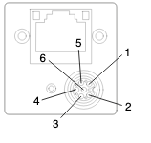

The power (+) should connect to pin 1 and the power (-) should connect to pin 6. Pins 4 and 5 are the camera GPIO and correspond to line 2 and 3 (important when programming triggering) and pins 2 and 3 are for an opto-coupled I/O line. The camera housing has a 3-wire cable – red, black, and yellow. The red one is power and goes to pin 1, black one is ground and goes to pin 6, and the yellow is the Pi I/O. This yellow wire can go either 2 or 3 but it is currently connected to 4 (line 2). Please double check where the yellow wire is connected to.

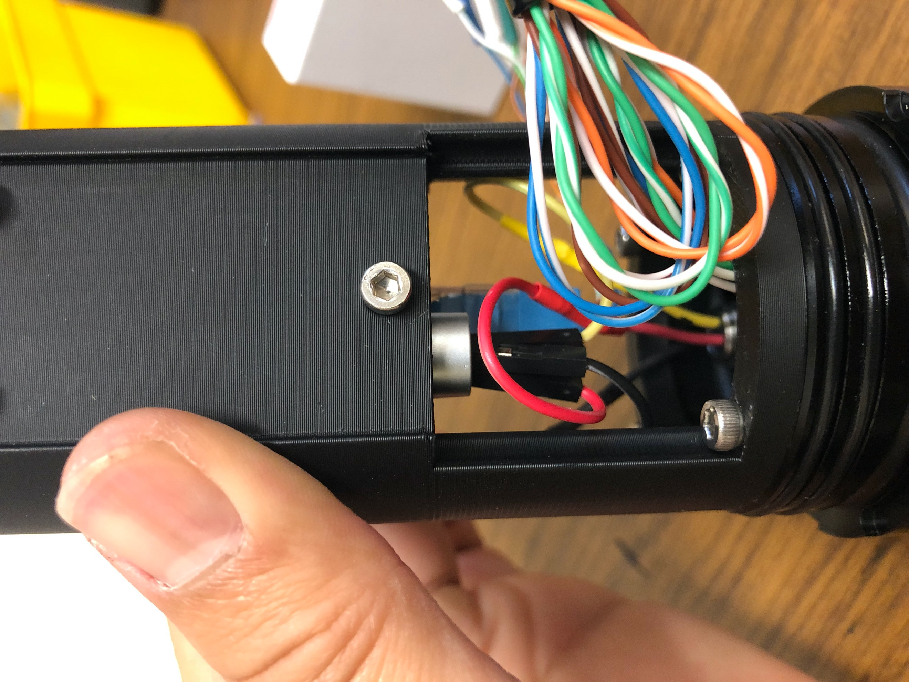

**Optics**

This camera records at 168 fps and at resolution of 1920 x 1200. The camera sensor itself has a format of 1/2.3" and pixel size of 3.45 µm. It is color camera with an IR cut filter.

The Basler camera uses an [arducam varifocal camera lens](https://www.arducam.com/product/arducam-4-12mm-varifocal-c-mount-lens-for-raspberry-pi-hq-camera-with-c-cs-adapter/). A varifocal lens was selected in order ensure the camera could fit a 2 in diameter pressure housing and to have some degree of adjusting the image size. The lens’s focal length can be from 4 -12 mm (focal length needs to be larger than the camera sensor’s diagonal of 7.9 mm so that they don’t become blurry). Different focal lengths results in different field of views. Calculating the field of view based on the focal length and camera sensor dimensions can be found [here](https://wavelength-oe.com/optical-calculators/field-of-view/) and also [here](https://www.princetoninstruments.com/learn/camera-fundamentals/field-of-view-and-angular-field-of-view) (if working distance is known and focal length is not). There is a python script that will be provided that has these equations so that you can compare the actual field of view to the calculated one.

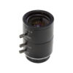

The first knob on top is for the focal length (where it says tele – wide). The camera lens does not come with a clear indicating markers on what the focal length is, but it is safe to assume that starting on the right is 4 mm and turn all the way clockwise is 12mm. The second knob is the aperture ring which adjusts the amount of light comes to the lens. The third knob is the manual focus ring. To secure the adjustments to the lens, turn the knobs clockwise. The optical format of the lens is 1/2”.

***Future work 6: Figure what the focal lengths at the different positions on the first knob***

[An Edmund optics polarizing filter](https://www.edmundoptics.com/p/m27-x-05-mounted-linear-glass-polarizing-filter/19575/) is attached to the lens to reduce glare and possible scattering of light from the water and/or ice when recording the laser sheet. The purchased polarizing lens has a diameter of 29 mm was meant to screw onto a previous camera lens (M27).

***Future work 7: Figure out a way to attach the polarizing filter to the camera lens and set it at an optimal position.***

**Programming**

The steps on how to program have not been completed. As previously mentioned in the “brain” section, the idea is to use the pypylon wrapper to program the camera. So far, only [pylon viewer](https://docs.baslerweb.com/overview-of-the-pylon-viewer) is installed on the raspberry pi and laptop used in the lab. This software allows you to quickly view the camera settings and change most of the camera settings via graphical user interface. It is a way to quickly see if the camera can connect to the Pi and see the current camera parameter settings before deployment. The software was installed using these [steps](https://www2.baslerweb.com/en/downloads/document-downloads/how-to-build-pylon-applications-on-raspberry-pi/).

Insert picture of software here

This application is useful because when adjusting the camera, it also provides the corresponding code that makes that same adjustment. There is a lot to explore using this software, so I highly recommend checking out the link to pylon viewer overview (putting it here [again](https://docs.baslerweb.com/overview-of-the-pylon-viewer)). There is also documentation found [here](https://docs.baslerweb.com/features) that tells how to write the code in python by selecting your camera model, selecting the feature you wish to adjust on the left panel and scrolling down and choosing python to see the sample code on the middle panel.



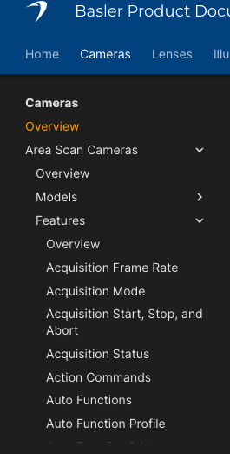

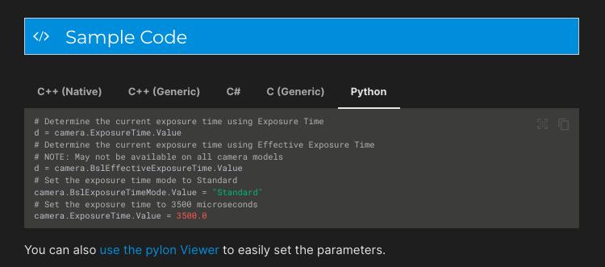

The [github link for pypylon](https://github.com/basler/pypylon) includes a bunch of sample python scripts. These sample scripts are already accessible on the Pi if you go to the pylon directory. As previously mentioned, I have not been able to install the pylon module so before writing the code to control the camera in the python script that runs upon boot, pypylon needs to be installed.

***Future Work 8: install pypylon***

[Trigger Image Acquisition](https://docs.baslerweb.com/triggered-image-acquisition)

To have the camera capture images or a burst of images after a trigger (turning on the laser), you need to program the camera to have one of the GPIO pins to input the voltages from the PI yellow wire. Based on the link provided, this is possible when using a hardware trigger source (it may be the case that there needs to be another I/O pins connected to another camera GPIO ports – which may include a more complicated lines of code that may need to thread 2 PWM signals so therefore needs to swap out the 3-wire cable to a 4 wire cable). There needs to be some while loop with a time limit that has the laser pulsing and capture images when the laser is on. It should look like this:

#previous initialization laser code stuff here

Def camera_settings():

#stuff that adjusts settings

Def camera_capture():

#have the code that controls trigger here

Tick = datetime.now()

Time_limit = 90 #amount of time recording in seconds – can be changed

While True:

Camera_settings():

#laser stuff

#camera stuff

If (datetime.now() – tick).seconds > time_limit:

Break

GPIO.cleanup()

Print(“stopped at:”, #insert code thar reads output of rtc here)

Os.system(‘sudo shutdown -h now’)

Datetime module is used to set the amount of time the laser camera system is operational before shutting down via os module. It is important to know the battery level and the total power consumption of each component before deployment for that specific amount of time.

***Future Work 9: figure the lines of code to have the images acquired based on the pwm signal trigger***

**Summary:** The camera is in a 2 in diameter, 150 mm long pressure housing with a camera lens and polarizing filter. There is an ethernet connection required for the camera and is powered by 13V and GND wires. A yellow wire is connected to one of the GPIO pins of the camera and this wire is used to trigger an event. There is a lot of exploring and diving into the unknown with the camera such as knowing the field of view of the lens, the capabilities of the polarizing filter, and how to write the code to program the camera to fit our interests.

***Priority of Future Work:***

* ***Future Work 8: install pypylon***
* ***Future Work 9: figure the lines of code to have the images acquired based on the pwm signal trigger***
* ***Future Work 4: These lines can be edited to better suit the needs of the scientists such as writing another function that has the button commands and a sleep command or make the whole thing a class.***
* ***Future work 6: Figure what the focal lengths at the different positions on the first knob***
* ***Future Work 5: figure out a where files will be saved and program it to have the time it was made – datetime module can be used instead***
* ***Future work 7: Figure out a way to attach the polarizing filter to the camera lens and set it at an optimal position.***
* ***Future Work 2: include a battery monitor so that the battery is not damaged and can be rechargeable. A simple monitor circuit and python script that programs the circuit was given to me by Noah. This can be incorporated to the circuit.***
* ***FUTURE WORK 1: work on soldering the red wire in place or an alternative way to safely securing the wire in place***
* ***Future Work 3: Ensure a way the ethernet wiring does not interfere the space where the flash drive will be.***